**1st Assignment with PIR, Temperature sensors and buzzers.**

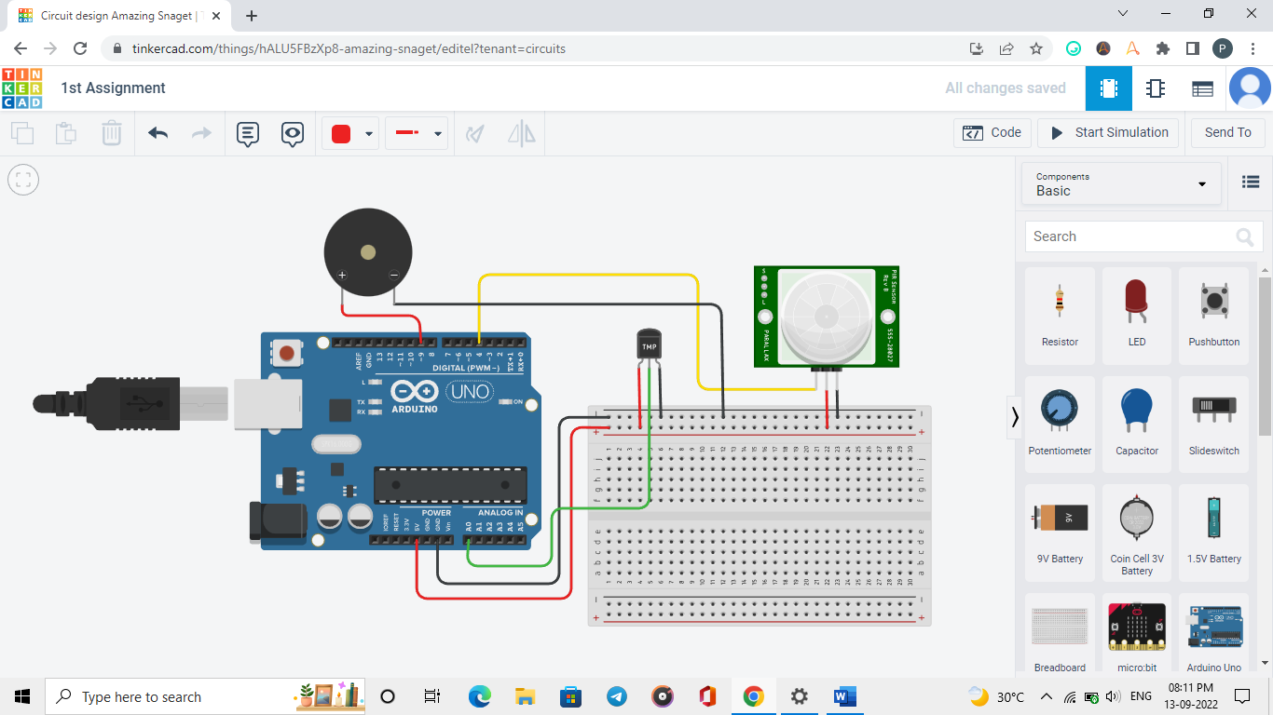

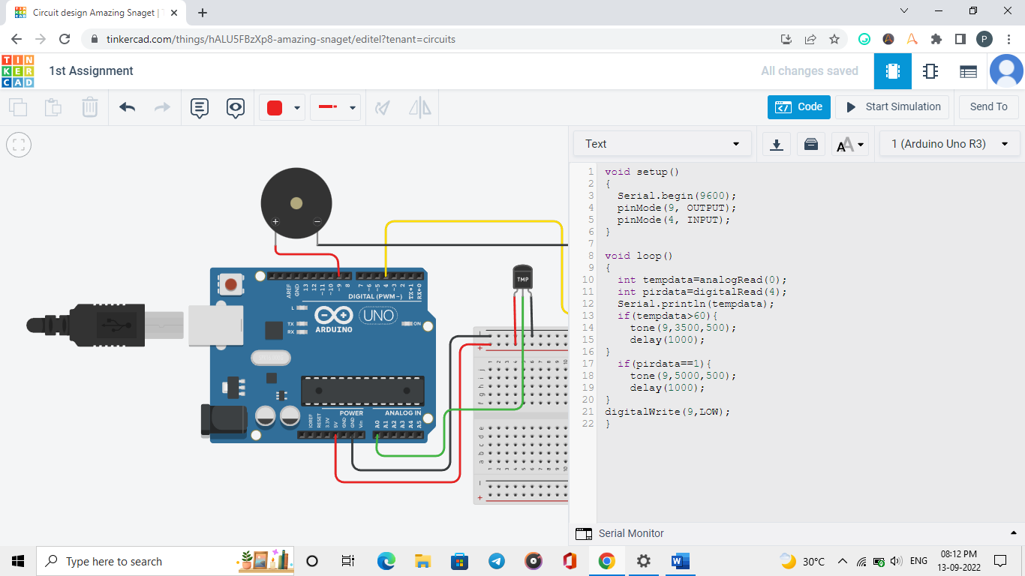

**Code:**

**void setup()**

**{**

**Serial.begin(9600);**

**pinMode(9, OUTPUT);**

**pinMode(4, INPUT);**

**}**

**void loop()**

**{**

**int tempdata=analogRead(0);**

**int pirdata=digitalRead(4);**

**Serial.println(tempdata);**

**if(tempdata>60){**

**tone(9,3500,500);**

**delay(1000);**

**}**

**if(pirdata==1){**

**tone(9,5000,500);**

**delay(1000);**

**}**

**digitalWrite(9,LOW);**

**}**